Software Requirements Specification

Version 1.1.0

THEGIOIDIDONG

GROUP 3

HCM22_CPL_JAVA_03

# Table of Contents

Table of Contents 1

1.0. Introduction 2

1.1. Purpose 2

1.2. Scope of Project 2

1.3. Glossary 2

2.0. Overall Description 2

2.1 System Environment 2

2.2 Functional Requirements Specification 3

**2.2.1. Thegioididong Admin Use Case** 3

**2.2.2. Thegioididong User Use Case** 7

2.3 User Characteristics 11

2.4 Non-Functional Requirements 11

*3.0.* *Requirements Specification* 11

3.1 External Interface Requirements 11

3.2 Functional Requirements 11

3.2.5 Admin User Management 15

3.3 Detailed Non-Functional Requirements 16

**3.3.1** **Logical Structure of the Data** 16

# 1.0. Introduction

## 1.1. Purpose

The purpose of this document is to present a detailed description of the Thegioididong Store System . It will explain the purpose and features of the system, the interfaces of the system, what the system will do, the constraints under which it must operate and how the system will react to external stimuli. This document is intended for both the stakeholders and the developers of the system and will be proposed to the potential clients for its approval.

## 1.2. Scope of Project

This software product will be the website for buyers and the manager THEGIOIDIDONG.

## 1.3. Glossary

|  |  |
| --- | --- |
| **Term** | **Definition** |
| Administrator | Users could login to update data |
| User | Users want to find and buy items |

## 

# 2.0. Overall Description

## 2.1 System Environment

End users could be project managers, quality assurance team and other project members. There are more than 500 possible users.

TBD

## 2.2 Functional Requirements Specification

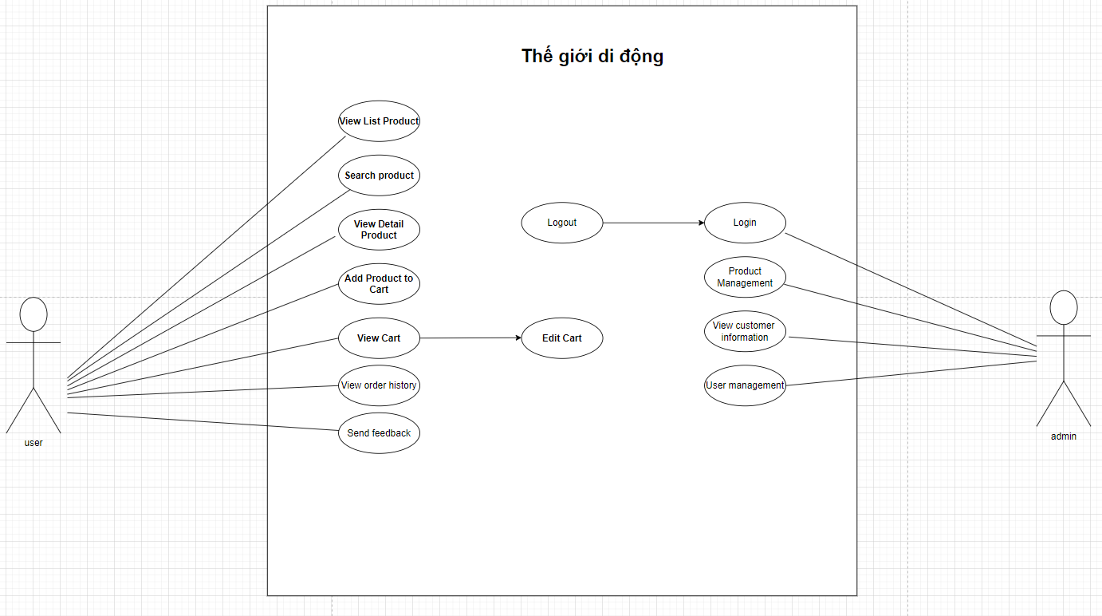

**Figure 1 – Thegioididong Store System Use Case**

This section outlines the use cases for each of the active users separately.

### 

### **2.2.1. Thegioididong Admin Use Case**

Use case : **Admin Login**

**Diagram :**



**Brief Description**

The admin accesses the Thegioididong website to login.

**Initial Step-By-Step Description**

Before this use case can be initiated, the user has already accessed the login page on Thegioididong website.

1. The admin accesses the login page.

2. The admin fills username/password.

3. The system validates input and response error message if error happened.

4. The system redirect to add product page if correct username/password.

5. The system allows the user to perform other activities.

Use case : **Admin Logout**

**Diagram :**



**Brief Description**

The admin accesses the Thegioididong website to login.

**Initial Step-By-Step Description**

Before this use case can be initiated, the user has already accessed the login page on Thegioididong website.

1. The admin accesses the login page.

2. The admin fills username/password.

3. The system validates input and response error message if error happened.

4. The system redirect to add product page if correct username/password.

5. The admin click on the logout icon to return to the login page.

Use case : **Admin Product Management**

**Brief Description**

The admin accesses the THEGIOIDIDONG website to add new product, edit product, delete product .

**Initial Step-By-Step Description**

Before this use case can be initiated, the user has already accessed the THEGIOIDIDONG website with role admin.

1. The admin accesses the product page.

2. The admin fills in new product information and clicks add product.

3. The system inserts new products to the database and clear form.

4. The system allows the admin to perform other activities.

Use case : **Admin View Customer information**

**Diagram :**



**Brief Description**

The admin accesses the Thegioididong website to view customer information.

**Initial Step-By-Step Description**

Admin need to login to use this function

1. Admin access customer management

2. The system will display a list of customer information

Use Case: **User management**

**Diagram:**

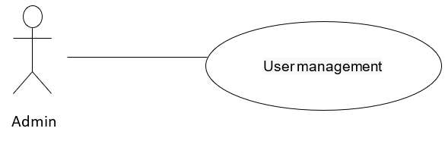

**Brief Description**

Admin accesses the Thegioididong to view User, add User, edit User, Delete User.

**Initial Step-By-Step Description**

Admin need to login to use this function

1. Admin accesses the home page.

2. The system redirects to a list of all User.

3. Admin clicks “Add User” on top right.

4. Admin enter information User.

5. Admin input discount value.

6. Admin clicks “Lưu”.

7. System update information in database.

8. System returns to home page.

### **2.2.2. Thegioididong User Use Case**

Use case : **View Product List**

**Diagram :**

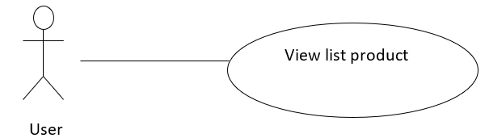

**Brief Description**

User accesses the Thegioididong website and see product list.

**Initial Step-By-Step Description**

Before this use case can be initiated, the Customer has already accessed the view page on Thegioididong website.

1. The system get all products in stock.

2. The system show all products in stock to view page .

Use case : **User View Detail Product**

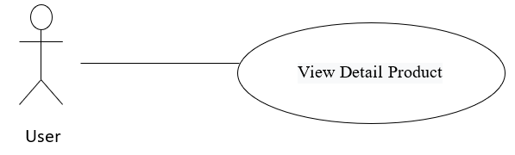

**Brief Description**

User accesses the Thegioididong website and choose Detail product.

**Initial Step-By-Step Description**

Before this use case can be initiated, view product list function must initial and the User accesses to products view page of thegioididong website..

1. The User chooses one product.

2. The system gets Detail information of that product.

3. The system shows product information to Detail product view page.

Use case : **User Add Product To Cart**

**Diagram :**

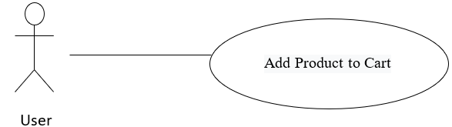

**Brief Description**

User accesses the Thegioididong website to order product.

**Initial Step-By-Step Description**

Before this use case can be initiated, view product list function must initial.and view specific product initial and the user accesses to specific product view page of thegioididong website.

1. User accesses to view product list page.
2. User accesses to view specific product view page.
3. User choose buy now to order product.
4. The system get detail product information add to cart.

**Use Case:** User View Cart

**Diagram:**

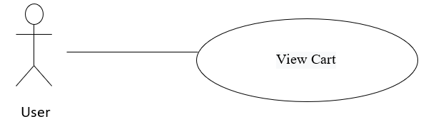

**Brief Description**

User accesses the Thegioididong to view cart.

**Initial Step-By-Step Description**

Customers don’t need to login to use this function

1. User accesses the home page.
2. The system redirects to list all products.
3. User clicks view cart on top right.
4. The system redirects to cart page.
5. The system allows the user to perform other activities.

**Use Case:** User Edit Cart

**Diagram:**



**Brief Description**

Users access the Thegioididong to edit carts.

**Initial Step-By-Step Description**

Customers don’t need to login to use this function

1. User accesses the home page.
2. User clicks view cart on top right.
3. The system redirects to cart page.
4. The system allows users to edit increase, decrease quantity, change product color and delete product.

**Use Case:** User search product

**Diagram:**

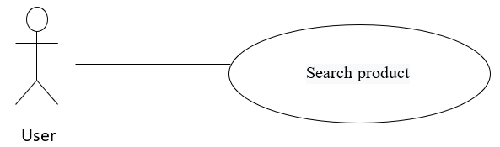

**Brief Description**

User accesses the Thegioididong to search product.

**Initial Step-By-Step Description**

1. User accesses the home page.
2. User fills in the search box the product that the customer wants to find
3. The system redirects to a result set of search
4. The system allows the customer to perform other activities.

**Use Case:** User View order history

**Diagram:**



**Brief Description**

User accesses the Thegioididong to view order history.

**Initial Step-By-Step Description**

1. User accesses the home page.
2. The system redirects to list all products.
3. User clicks on order history at the top right.
4. The system redirects to the order history page.
5. Users can see the list of purchased orders.

**Use Case:** User Send feedback product

**Diagram:**



**Brief Description**

User accesses the Thegioididong Send feedback product.

**Initial Step-By-Step Description**

1. The User chooses one product.
2. The system shows product information to detail product view page.
3. Users can send feedback about that product
4. Feedback of user will be displayed in the product details section

## 2.3 User Characteristics

TBD

## 2.4 Non-Functional Requirements

TBD

# *3.0. Requirements Specification*

## 3.1 External Interface Requirements

TBD

## 3.2 Functional Requirements

The Logical Structure of the Data is contained in Section 3.3.1.

3.2.1 Admin Login

|  |  |
| --- | --- |
| **Use Case Name** | Admin Login |
| **XRef** | Section 2.2.1, Admin Login |
| **Trigger** | The user accesses the login page of Thegioididong website |
| **Precondition** | The login form display |
| **Basic Path** | 1. The admin accesses the login page.  2. The admin fills username/password.  3. The system validates input and response error message if an error happened.  4. The system redirect to add product page if correct username/password.  5. The system allows the user to perform other activities. |
| **Alternative Paths** | None |
| **Postcondition** | None |
| **Exception Paths** | None |
| **Other** | None |

3.2.2 Admin Product Management

|  |  |
| --- | --- |
| **Use Case Name** | Admin Product Management |
| **XRef** | Section 2.2.1, Admin Product Management |
| **Trigger** | The admin accesses the Thegioididong website |
| **Precondition** | None |
| **Basic Path** | 1. Admin access the product page.  2. Admin fill in new product information and click add new product, edit product, delete product.  3. The system will follow the administrator's request (add new products, edit products, delete products).  4. The system allows the administrator to perform other operations. |
| **Alternative Paths** | None |
| **Postcondition** | None |
| **Exception Paths** | None |
| **Other** | None |

3.2.3 Admin View User Detail

|  |  |
| --- | --- |
| **Use Case Name** | Admin View User Detail |
| **XRef** | Section 2.2.1, Admin View User Detail |
| **Trigger** | The admin accesses the Thegioididong website |
| **Precondition** | None |
| **Basic Path** | 1. Admin access customer management  2. The system will display a list of customer information. |
|  | None |
| **Postcondition** | None |
| **Exception Paths** | None |
| **Other** | None |

3.2.4 Admin View Detail Product

|  |  |
| --- | --- |
| **Use Case Name** | Admin view detail product |
| **XRef** | Section 2.2.1, Admin View Detail Product |
| **Trigger** | The admin accesses the Thegioididong website |
| **Precondition** | None |
| **Basic Path** | 1. The admin accesses to view detail product.  2. The system allows the admin to perform other activities . |
| **Alternative Paths** | None |
| **Postcondition** | None |
| **Exception Paths** | None |
| **Other** | None |

## 3.2.5 Admin User Management

|  |  |
| --- | --- |
| **Use Case Name** | Admin User Management |
| **XRef** | Section 2.2.1, Admin User Management |
| **Trigger** | The admin accesses the Thegioididong website |
| **Precondition** | None |
| **Basic Path** | 1. The administrator accesses the customer management page.  2. Admin fill in new product information and click add new user, edit user, delete user.  3. The system will follow the administrator's request (add new user, edit user, delete user).  4. The system allows the administrator to perform other operations. |
| **Alternative Paths** | None |
| **Postcondition** | None |
| **Exception Paths** | None |
| **Other** | None |

## 

## 3.3 Detailed Non-Functional Requirements

### **3.3.1 Logical Structure of the Data**

The logical structure of the data to be stored on the system is given below: